SCHOOL OF ELECTRICAL, ELECTRONIC AND COMPUTER ENGINEERING
ENEL3SF –SOFTWARE ENGINEERING 2
GROUP 10
NAMES | STUDENT NUMBER
MARINDI MPHO | 223068894
RAMAKOPA KOKETSO | 224060934
ZULU BONGA | 224043843
ZWANE BANELE | 224006427
NGCOBO SIBONELO | 224007550

Introduction 2
1.Requirements Verification and Database Testing 3
1.1Verification Methods 3
1.2.Requirements Verification Table 3
1.3.Database Test Summary 4
1.4. Detailed Test Evidence 4
1.4.1 Volunteer Profile Verification 4
1.4.2 Organisation Verification 5
1.4.3 Organisation Member Relationship 5
1.4.4 Opportunity Verification 6
1.4.5 Application Workflow Verification 6
1.4.6 Skill Catalogue Verification 7
1.4.7 Volunteer Skill Relationship 7
1.4.8 Opportunity Skill Relationship 8
1.4.9 Notification Verification 8
1.4.10 Chatbot FAQ Verification 9
1.5 Key Findings and Issues Identified 9
1.6 Overall Verification Result 10
2. System Integration and Final Prototype testing 10
2.1 Purpose and integration scope 10
2.2 Integrated system configuration 11
2.3 Test method and evidence 11
2.3 Prototype integration test results 12
2.4 Detailed discussion of integration scenarios 13
2.4.1 Volunteer opportunity discovery and application 13
2.4.2 Organisation review and application acceptance 15
2.4.3 Opportunity creation and database persistence 16
2.4.4 Dashboard and existing database records 20
2.4.5 Additional PostgreSQL integration and data persistence evidence 21
2.5 Interpretation, quality observations and residual risks 24
2.6 Evaluation and outstanding verification 25
3 Defect Log and quality metrics 26
3.1 Defects detected 26
3.2 quality metrics 27
3.3 Verified Github Link 27
Conclusion 28

Introduction
To enhance the way volunteers and organizations communicate and oversee community events, the Community Volunteer Coordination Platform was created. While organizations can develop opportunities, manage applications, and track volunteer involvement, the system offers a central platform where volunteers can build profiles, browse available opportunities, apply for activities, and manage their participation. A frontend, backend, and PostgreSQL database are used in the system's implementation. The database contains data about users, volunteer profiles, organizations, opportunities, apps, and talents; the frontend creates user interfaces; and the backend manages system requests and communication. The system's implementation, requirements of coverage, database design and testing, component integration, version control, and the development of a finished Minimum Viable Product are all covered in this report.

1.Requirements Verification and Database Testing

1.1Verification Methods
Verification was performed in pgAdmin by executing SELECT queries against the implemented PostgreSQL tables and examining the returned records. The objective was not only to confirm that tables exist, but also to confirm that realistic project data is stored in the correct structures and that relationship tables contain valid links between entities.
For each major requirement, the expected database behaviour was compared with the actual query result. A requirement was marked PASS where the supplied evidence directly demonstrates the required database behaviour. Where the evidence supports only part of a requirement, the result is marked PARTIAL rather than overstating the level of verification.

1.2.Requirements Verification Table
ID | Requirement | Expected behaviour | Actual result | Status
RV-01 | Volunteer registration and profile storage | Volunteer Profile stores volunteer identity, contact details, location and availability. | 6 volunteer profiles are present with names, phone numbers, locations and availability. | PARTIAL - profile persistence verified; direct Users-table registration evidence not included.
RV-02 | Organisation registration and membership | Organisation details are stored and administrator accounts are linked to organisations. | 2 organisations are present and Organisation Member links Organisation 1 to User 4 and Organisation 2 to User 6 as admins. | PASS
RV-03 | Opportunity creation and storage | Organisations can create volunteer opportunities linked to their Organisation ID. | 4 opportunity records are present, including Durban Beach Cleaning, Tree Trimming, Road cleaning and Street crossing assistance. | PASS
RV-04 | Volunteer application workflow | Applications link volunteers to opportunities and store status, application time and decision time. | 9 applications are present. Pending and accepted states are visible. Accepted records contain decision timestamps. | PASS
RV-05 | Skills and matching support | Skills are stored once and linked to volunteers and opportunities through junction tables. | 5 skills are stored; Volunteer Skill contains 2 links; Opportunity Skill links Opportunity 1 to Skill 3. | PASS
RV-06 | Application notification | The system can store a notification for a user's application result. | A notification record exists for User 1 confirming acceptance for Durban Beach Cleaning. | PASS
RV-07 | Chatbot FAQ knowledge base | The chatbot has stored questions, answers and searchable keywords. | 15 FAQ rows are present with registration, opportunity and application guidance. | PASS WITH OBSERVATION - duplicate FAQ records should be removed.

1.3.Database Test Summary
Test | Query | Expected result | Actual result | Outcome
TC-01 | SELECT * FROM volunteer_profile; | Volunteer profile records returned | 6 rows | PASS
TC-02 | SELECT * FROM organisation; | Organisation records returned | 2 rows | PASS
TC-03 | SELECT * FROM organisation_member; | Administrator-to-organisation links returned | 2 rows | PASS
TC-04 | SELECT * FROM opportunity; | Opportunity records returned | 4 rows | PASS
TC-05 | SELECT * FROM application; | Applications and decision states returned | 9 rows | PASS
TC-06 | SELECT * FROM skill; | Skill catalogue returned | 5 rows | PASS
TC-07 | SELECT * FROM volunteer_skill; | Volunteer-to-skill links returned | 2 rows | PASS
TC-08 | SELECT * FROM opportunity_skill; | Opportunity-to-skill link returned | 1 row | PASS
TC-09 | SELECT * FROM notification; | Application-result notification returned | 1 row | PASS
TC-10 | SELECT * FROM chatbot_faq; | FAQ knowledge-base records returned | 15 rows; duplicates observed | PASS / DATA QUALITY ISSUE

1.4. Detailed Test Evidence

1.4.1 Volunteer Profile Verification
The Volunteer Profile query returned six records. The data includes volunteer names, phone numbers, locations and availability information. This confirms that volunteer profile information is being stored and retrieved successfully. It also shows that the database can support multiple registered volunteers rather than only a single test account.
Figure 1. Volunteer Profile records returned by PostgreSQL.

1.4.2 Organisation Verification
The Organisation query returned two organisation records. Each organisation has its own Organisation ID, name, email, phone number, address and verification status. Both records are currently marked pending, which is consistent with an implementation where organisation verification is handled as a separate approval step.
Figure 2. Organisation records stored in the database.

1.4.3 Organisation Member Relationship
The Organisation Member table contains two administrator links. Organisation 1 is linked to User 4 and Organisation 2 is linked to User 6, both with the member role admin. This verifies that user accounts can be associated with the organisation they manage.
Figure 3. Organisation-to-user administrator relationships.

1.4.4 Opportunity Verification
Four volunteer opportunities are stored in the Opportunity table. The records are linked to Organisation IDs and include titles and descriptions. The presence of multiple opportunities linked to different organisations confirms that the system supports organisation-specific opportunity creation and storage.
Figure 4. Opportunity records created by organisations.

1.4.5 Application Workflow Verification
The Application table contains nine records linking volunteers to opportunities. The status column includes both pending and accepted applications. Accepted records have a populated Decision At timestamp, while the pending record has a null decision time. This behaviour is correct because a decision timestamp should only be recorded after an organisation accepts or rejects an application.
Figure 5. Application records showing pending and accepted states.

1.4.6 Skill Catalogue Verification
Five skills are stored in the Skill table: First Aid, Teaching, Cleaning, Computer Skills and Event Organisation. Storing skills in a separate table reduces repetition and allows the same skill to be linked to multiple volunteers or opportunities.
Figure 6. Skill catalogue returned from PostgreSQL.

1.4.7 Volunteer Skill Relationship
The Volunteer Skill junction table contains two records linking Volunteer 1 to Skill 1 and Skill 3. This verifies the many-to-many database structure used to associate volunteers with multiple skills.
Figure 7. Volunteer-to-skill relationship records.

1.4.8 Opportunity Skill Relationship
The Opportunity Skill junction table links Opportunity 1 to Skill 3. This verifies that required or relevant skills can be associated with a volunteer opportunity independently of the opportunity record itself.
Figure 8. Opportunity-to-skill relationship record.

1.4.9 Notification Verification
The Notification table contains a record for User 1 stating that the application for Durban Beach Cleaning has been accepted. The record also stores the read state and creation timestamp. This provides database evidence that application decisions can result in user notifications.
Figure 9. Stored notification for an accepted volunteer application.

1.4.10 Chatbot FAQ Verification
The Chatbot FAQ table contains questions, answers and keyword fields used to support the platform chatbot. The stored content covers registration, finding opportunities, applying and checking application status. However, repeated questions are visible in the returned rows. The chatbot data is therefore present and functional at the database level, but duplicate FAQ records should be removed before final submission.
Figure 10. Chatbot FAQ knowledge-base records.

1.5 Key Findings and Issues Identified
Finding | Assessment
Core data persistence | Volunteer profiles, organisations, opportunities, applications and skills are all populated with realistic records.
Application decision workflow | Accepted applications include decision timestamps while pending applications retain a null decision time, which is the expected database behaviour.
Relationship tables | Organisation Member, Volunteer Skill and Opportunity Skill contain valid links between their parent entities.
Notification support | The database contains an application-result notification, providing evidence that status changes can be communicated to users.
Chatbot data quality | The Chatbot FAQ table contains duplicate questions. These duplicates should be removed and a UNIQUE constraint on the question field should be considered to prevent recurrence.
Evidence gap | A direct Users-table screenshot was not included in the supplied evidence. Therefore, account creation itself is not marked fully verified in this individual report, even though volunteer and organisation-related records demonstrate downstream persistence.

1.6 Overall Verification Result
The database testing provides strong evidence that the core Community Volunteer Coordination Platform requirements are supported by the implemented PostgreSQL design. The strongest verified workflow is:
Organisation -> Opportunity -> Volunteer Application -> Decision -> Notification
The records also demonstrate supporting functionality for volunteer profiles, skills and chatbot FAQs. Based on the supplied database evidence, the database component is suitable for the final prototype, subject to the cleanup of duplicate chatbot FAQ records and completion of any separate end-to-end integration checks required by the project team.

2. System Integration and Final Prototype testing

2.1 Purpose and integration scope
This section documents the integration work and final prototype test evidence for VolunteerConnect, a web-based system that coordinates volunteers and community organisations. The objective of integration testing was to determine whether the user interface, application programming interface (API), and PostgreSQL database support the main workflow as a connected system rather than as isolated components.
The screenshots supplied from the running prototype demonstrate browsing opportunities, opening opportunity details, submitting a volunteer application, reviewing and accepting an application through the organisation interface, and creating a new opportunity that is subsequently visible in both the database and the volunteer-facing listing. They also show the organisation dashboard and stored user records. The screenshots provide evidence of the displayed results, they do not constitute automated test logs, performance measurements, or a full security audit.

2.2 Integrated system configuration
The prototype was run through a local browser session. The implementation uses HTML, CSS and JavaScript for the frontend, Node.js with Express for the backend API routes, and PostgreSQL for persistent records. The application modules share a common workflow:
Layer | Responsibility | Integration evidence
Frontend | Displays opportunities, application forms, applicant decisions and dashboard information. | Opportunity listing and details (Figures 1–2); applicant views (Figures 4 and 6); opportunity form (Figures 7–8).
Backend/API | Processes requests for opportunities, applications, status changes and dashboard summaries. | Success confirmations after submission, approval and creation (Figures 3, 5 and 10).
PostgreSQL database | Stores user accounts, volunteer opportunities and related records. | Stored user rows (Figure 14); opportunity rows before and after creation (Figures 9 and 11).

The main integration paths verified through the provided evidence were the volunteer journey from the opportunity list to the detail view and then to application submission, the organisation administrator journey from the applicant list to an accept decision and the resulting updated applicant status, and the organisation administrator journey from the opportunity form to a database record and the resulting updated public opportunity listing.
2.3 Test method and evidence
Manual black-box integration testing was used. A tester interacted with the live pages, observed system messages and screen updates, and compared selected interface results with PostgreSQL tables. A successful on-screen message was treated as interface-level evidence. Where database views showed a corresponding persisted record, the finding was classified as stronger end to end evidence.
The screenshots were captured at different moments, so displayed totals are point-in-time observations and should not be assumed to describe the same database state. Screenshots are positioned directly within their relevant test scenarios in Section 5.5 . Each image appears before its numbered caption and interpretation. Descriptions only claim actions and outcomes supported by the displayed evidence. Contact details have been masked where appropriate.

2.3 Prototype integration test results
Test and expected outcome | Observed prototype evidence
Browse opportunities: available activities appear with status and capacity | Tree Trimming and Road Cleaning displayed with open badges, View controls and 1/8, 1/10 counts (Figure 1).
Open details: selected opportunity information and Apply Now control appear. | Tree Trimming detail page shows organiser, location, date, 08:00–12:00, 1/8 volunteers and Apply Now (Figure 2).
Open details: selected opportunity information and Apply Now control appear. | “Application submitted successfully” browser message was displayed (Figure 3). A matched application row was not separately shown for this exact click.
Review applicants: organisation administrator can see application records. | Applicant screen shows opportunities, volunteer names, statuses and Accept/Reject buttons (Figure 4).
Accept application: status changes from pending to accepted. | Application accepted confirmation appears (Figure 5); the highlighted Tree Trimming application subsequently reads accepted (Figure 6).
View organisation statistics: dashboard displays summary totals. | Dashboard shows 2 opportunities, 3 applications and 2 accepted volunteers at capture time (Figure 13). Calculations were not independently reconciled.
Create opportunity: administrator enters details and saves a new activity | Street crossing assistance form completed (Figure 8) and success message displayed (Figure 10).
Persist new opportunity: new database row exists. | Opportunity table increased from 3 rows (Figure 9) to 4 rows including Street crossing assistance (Figure 11).
Publish opportunity: saved activity appears on volunteer list. | Street crossing assistance appears as open with 0/3 volunteers and a View option (Figure 12).
User storage: accounts exist in database. | The users table displays 5 stored rows with roles and active status (Figure 14). No registration UI sequence was supplied.

2.4 Detailed discussion of integration scenarios

2.4.1 Volunteer opportunity discovery and application
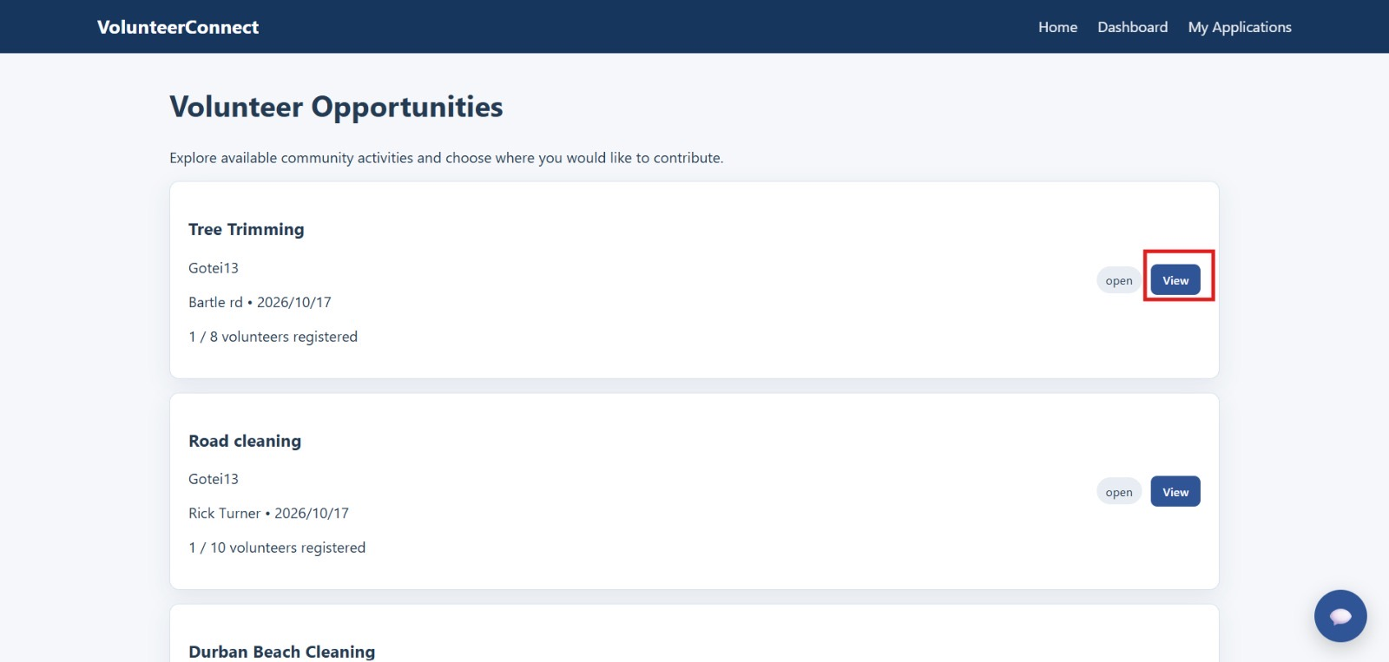
Figure 1. Volunteer opportunities list showing activities, open status, View controls and registered-volunteer counts.
Observed result. The opportunities page displays activity names, organisation details, status and volunteer-capacity information. Tree Trimming was shown as open with 1 of 8 places registered.
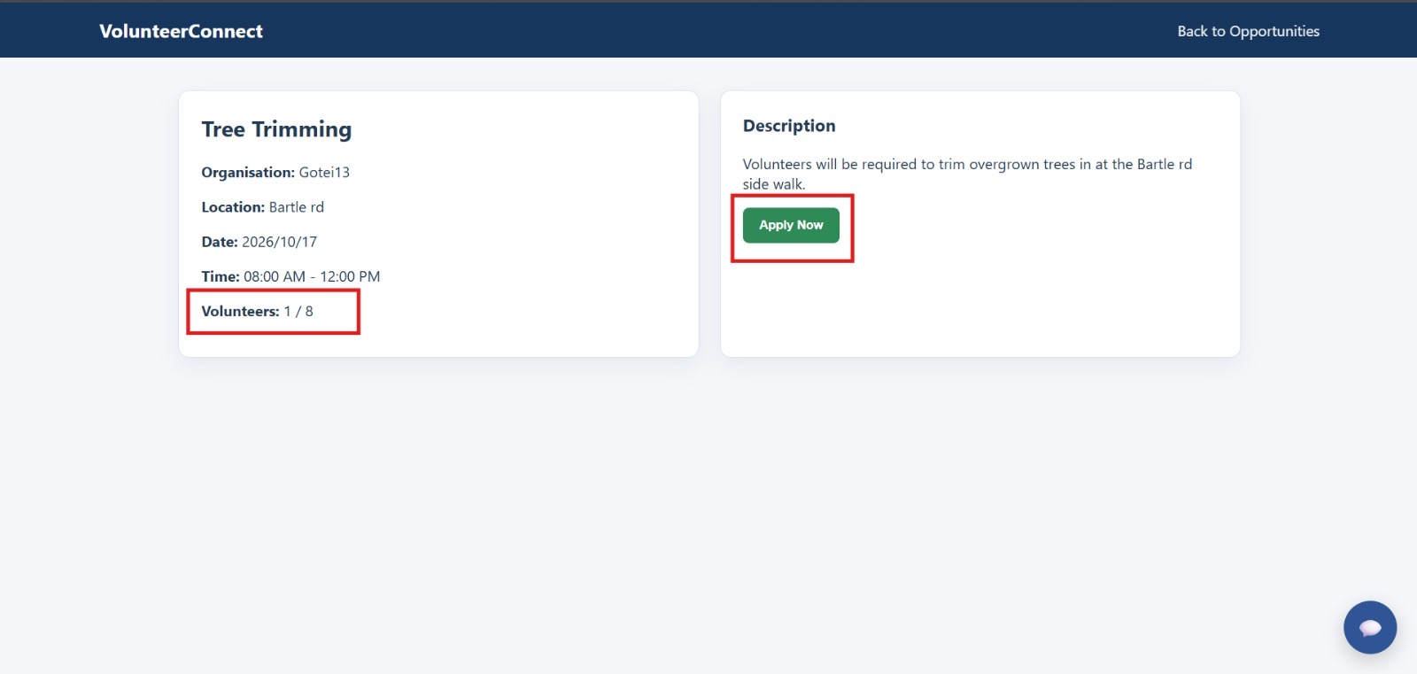
Figure 2. Tree Trimming details page showing the activity information and Apply Now control
Observed result. Selecting View opens the activity details, including the organisation, location, scheduled hours, description and Apply Now action.
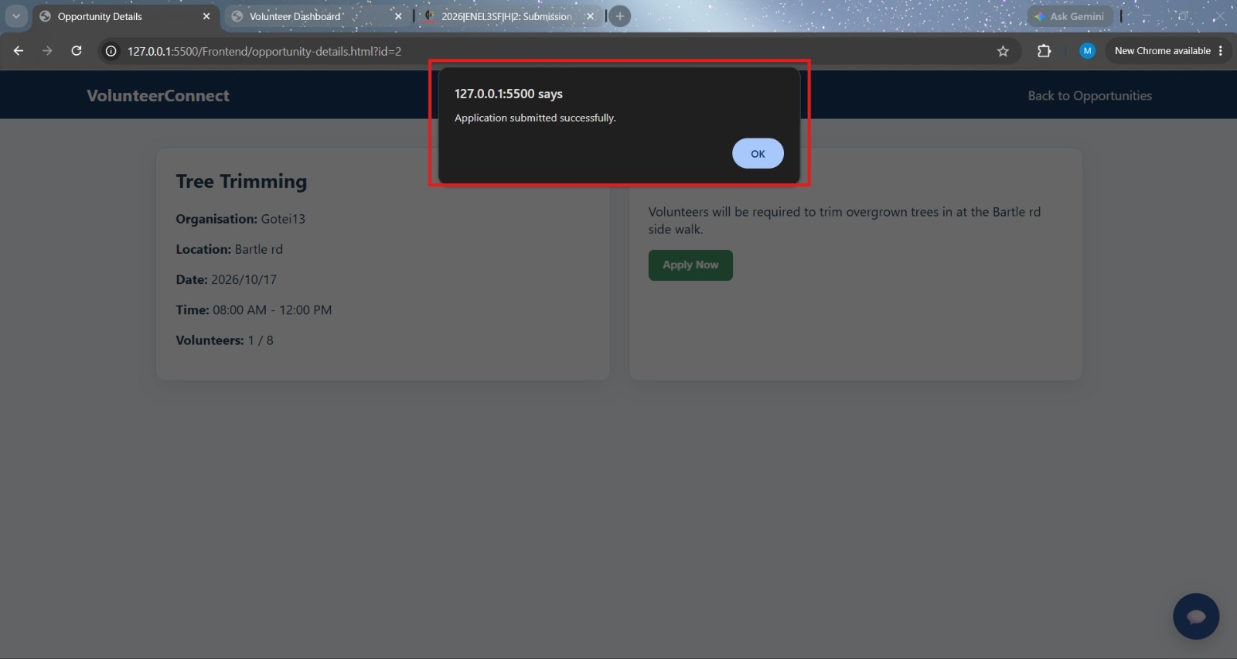
Figure 3. Browser confirmation after the volunteer submits an application
Observed result. The browser displayed “Application submitted successfully” after the volunteer applied. This is evidence of successful user-facing feedback; it does not independently confirm the exact row saved.
The displayed Tree Trimming opportunity was marked open and showed 1 of 8 volunteer places registered. Selecting View opened a dedicated detail page with the organisation, location, scheduled time, description and Apply Now button (Figures 1–2). A subsequent screenshot captured the system message "Application submitted successfully" (Figure 3). This confirms that the application action produced successful user-facing feedback in the tested session.

2.4.2 Organisation review and application acceptance
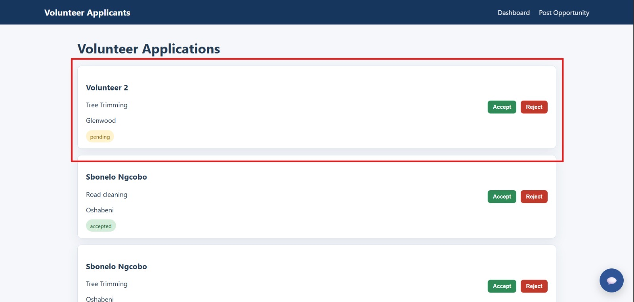
Figure 4. Organisation applicant management page displaying volunteer applications and decision controls.
Observed result. The applicant-management page lists volunteers, activities and pending or accepted application statuses, with Accept and Reject controls available.
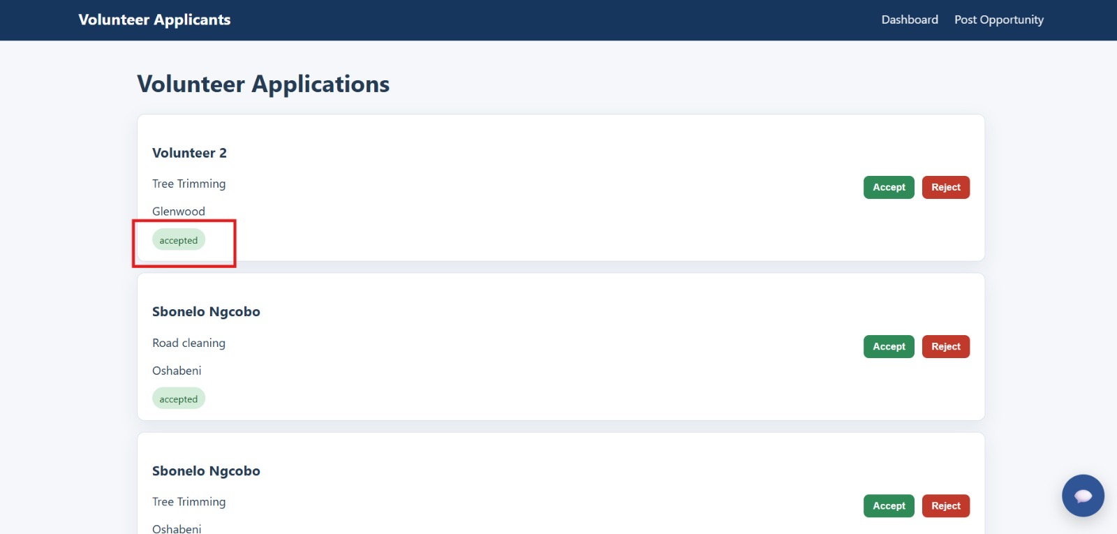
Figure 6. Applicant screen after the highlighted Tree Trimming application status changed to accepted.
Observed result. The highlighted Tree Trimming applicant changed from pending to accepted on the applicant-management screen, supporting the observed approval workflow.
The organisation-facing applicant page displayed volunteer records with a pending or accepted status and Accept and Reject controls. For the Tree Trimming application highlighted in the evidence, the system displayed an "Application accepted" confirmation after the administrator acted, and the displayed status changed from pending to accepted (Figures 4, 5–6). This provides visible evidence that the applicant-management interface supports review and the accept decision.

2.4.3 Opportunity creation and database persistence
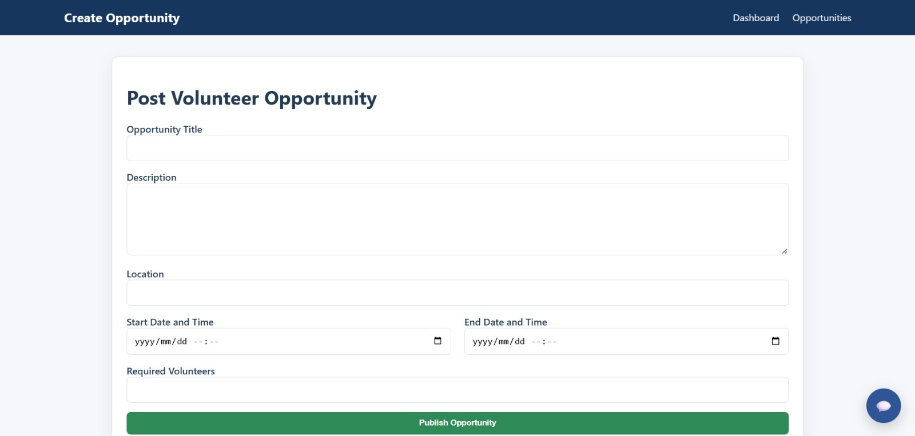
Figure 7. Blank Post Volunteer Opportunity form before entry of a new activity.
Observed result. The administrator was provided with a form for the opportunity title, description, location, dates, times and required number of volunteers.
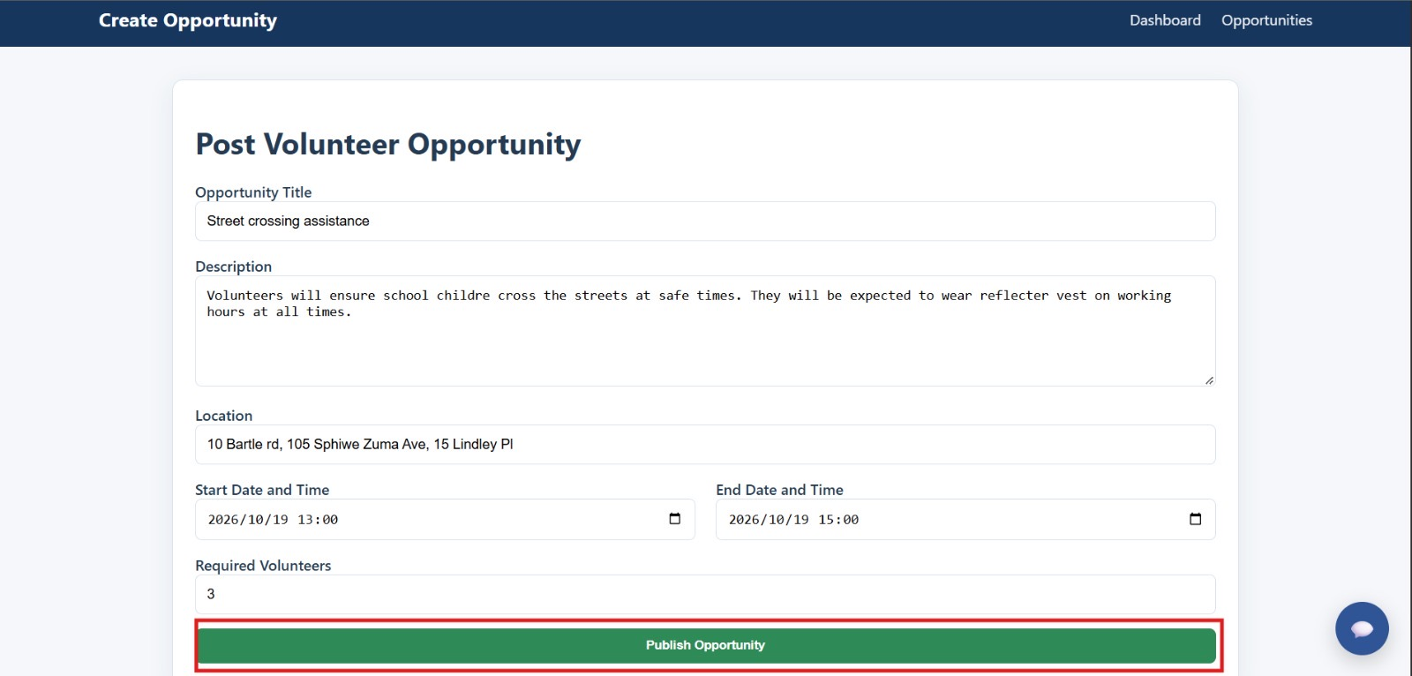
Figure 8. Completed Street crossing assistance opportunity form before publishing.
Observed result. The new Street crossing assistance opportunity was entered with its description, location, 19 October 2026 schedule and three required volunteers.
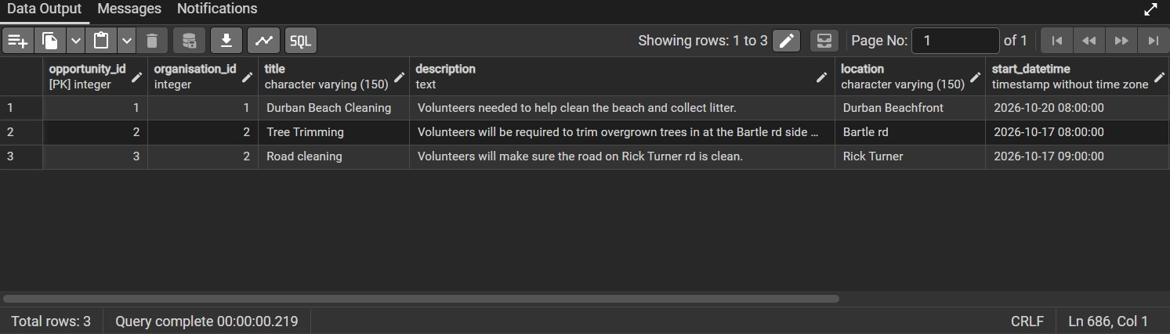
Figure 9. PostgreSQL opportunity table showing three records before the new activity was added.
Observed result. Before publishing the new opportunity, the PostgreSQL opportunity table contained three recorded activities.
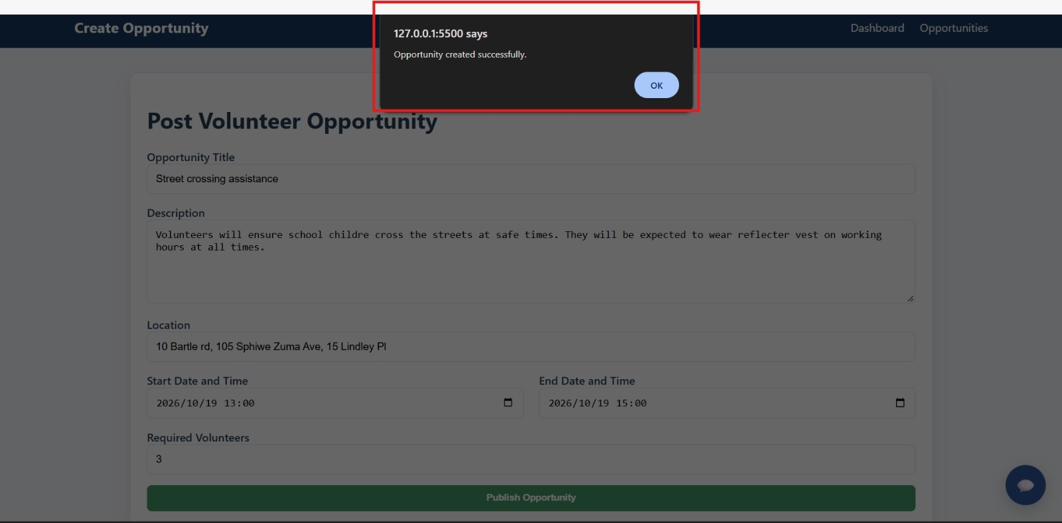
Figure 10. Browser confirmation after publishing the Street crossing assistance opportunity.
Observed result. The interface displayed “Opportunity created successfully” after the Publish Opportunity action.
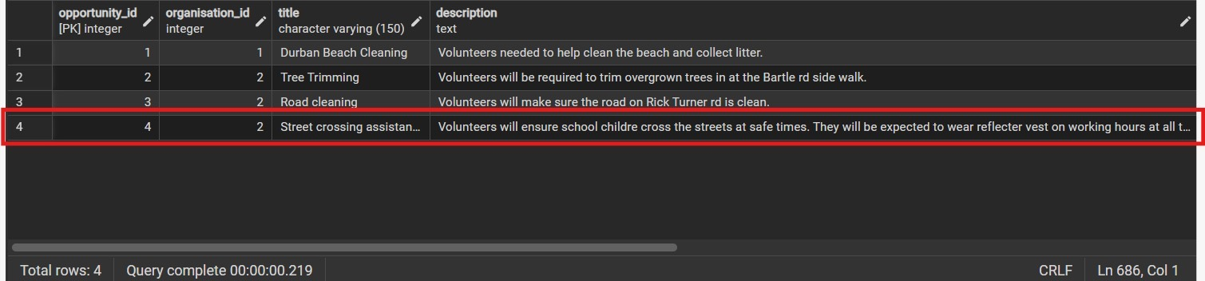
Figure 11. PostgreSQL opportunity table showing four entries, including Street crossing assistance.
Observed result. A later PostgreSQL query returned four activity records, including Street crossing assistance with opportunity ID 4, showing that the new record was stored.
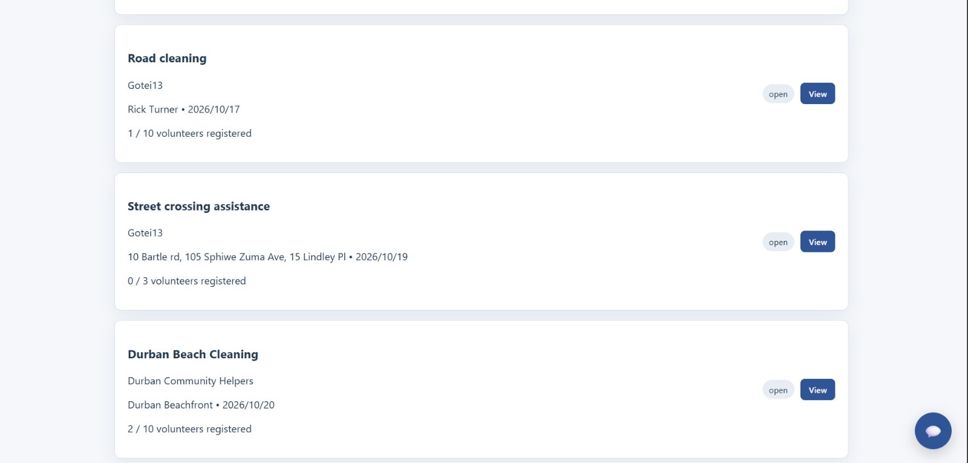
Figure 12. Updated opportunities list displaying Street crossing assistance as open with 0/3 volunteers.
Observed result. The newly created activity appeared on the public opportunity list with open status and 0 of 3 volunteers registered, confirming its availability to volunteers.
The strongest complete integration example is the creation of "Street crossing assistance." The administrator entered the title, description, location, scheduled start and end times (19 October 2026, 13:00 to 15:00), and a requirement for 3 volunteers (Figures 7–8). The browser then displayed "Opportunity created successfully" (Figure 10). Before creation, the PostgreSQL opportunity table contained 3 records (Figure 9); in the later capture it contained 4, including "Street crossing assistance" as an opportunity (Figure 11). Finally, the public opportunities page displayed that new activity as open with 0/3 volunteers registered (Figure 12). Taken together, this sequence demonstrates the path from creation to storage to display.

2.4.4 Dashboard and existing database records
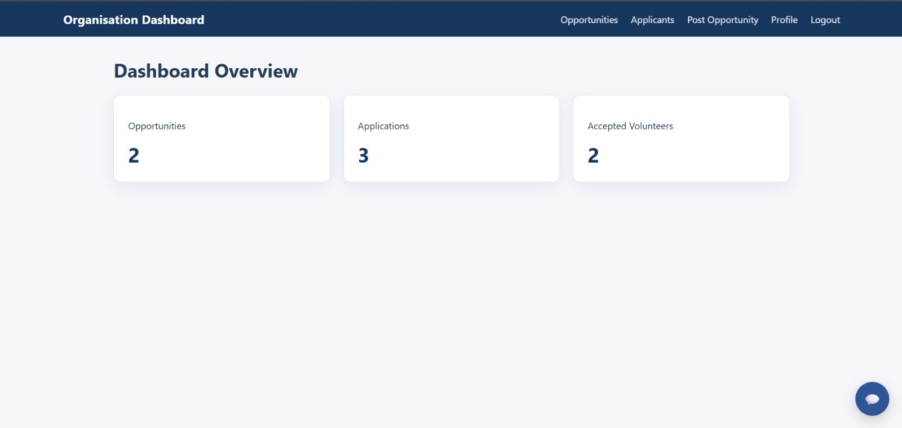
Figure 13. Organisation dashboard displaying 2 opportunities, 3 applications and 2 accepted volunteers.
Observed result. At the time of capture, the organisation dashboard displayed 2 opportunities, 3 applications and 2 accepted volunteers. These are organisation-facing point-in-time counters.
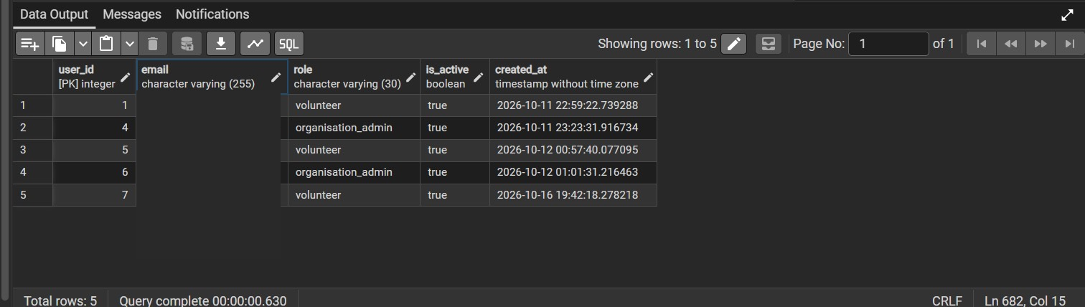
Figure 14. PostgreSQL users table showing five accounts and their roles; email values masked.
Observed result. The users table showed five stored accounts with volunteer and organisation-administrator roles. Email values are masked in the report copy.
An organisation dashboard screenshot displayed 2 opportunities, 3 applications and 2 accepted volunteers (Figure 13). The PostgreSQL users table also showed 5 user records with volunteer and organisation administrator roles (Figure 14). Different screens were captured at different points, and organisation-level dashboard counts should not be compared directly to a global opportunity-table row count.

2.4.5 Additional PostgreSQL integration and data persistence evidence
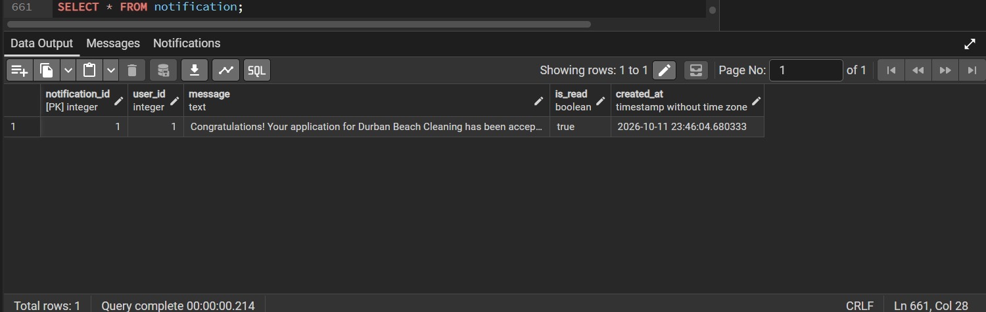
Figure 15. PostgreSQL notification table showing one saved acceptance notification, marked as read.
Observed result. The notifications table contained one acceptance-related message marked as read. Delivery or reading through the user interface is not established by this database screenshot.
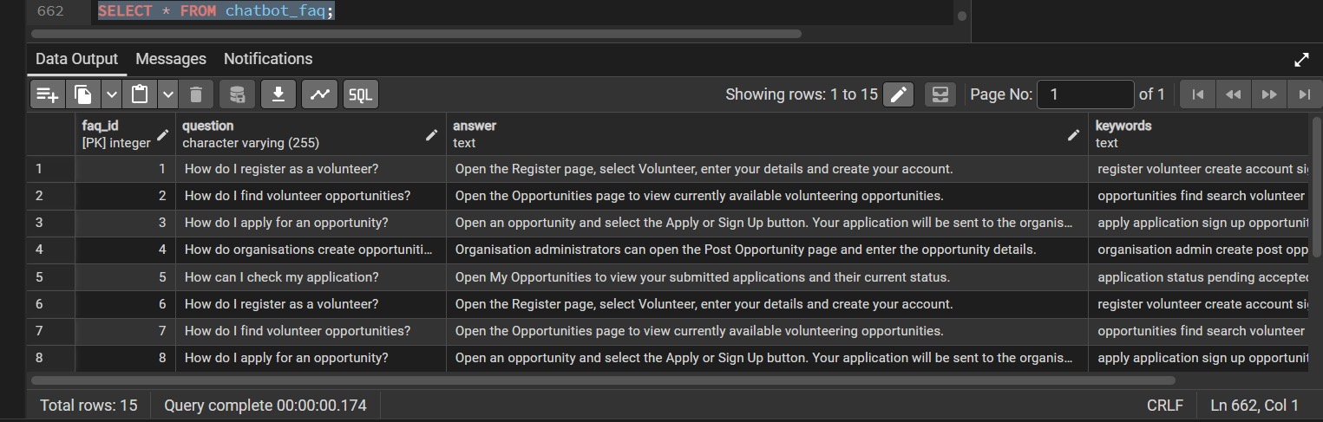
Figure 16. Chatbot FAQ table showing 15 stored rows; several visible questions are repeated.
Observed result. The chatbot FAQ table contained 15 entries. Several repeated questions were visible and should be reviewed for possible duplicate records.
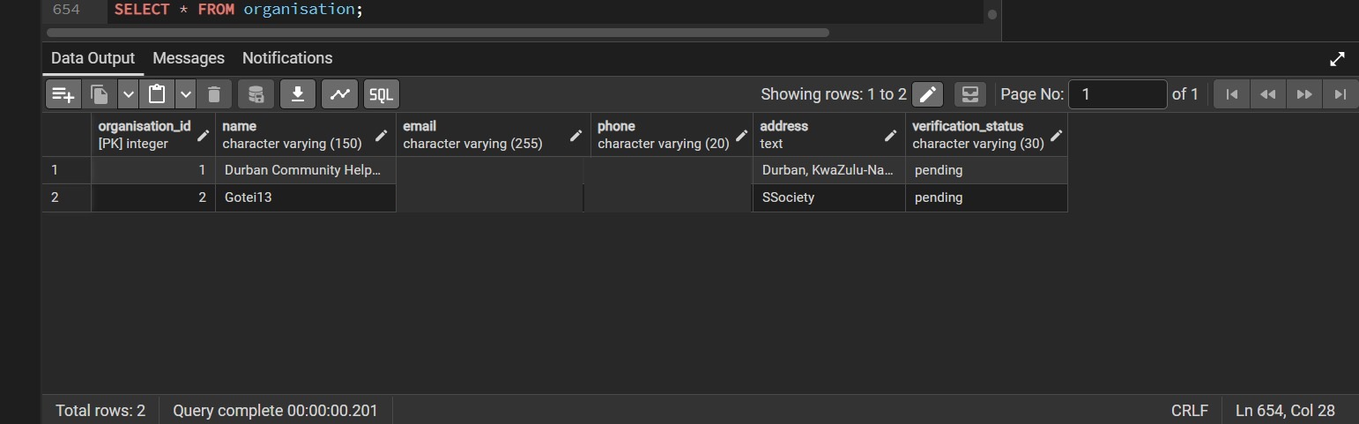
Figure 17. Organisation table with two saved organisations, both with pending verification status (contacts masked).
Observed result. Two organisation records were saved, and both displayed a pending verification status. Organisation approval is not demonstrated by this image.
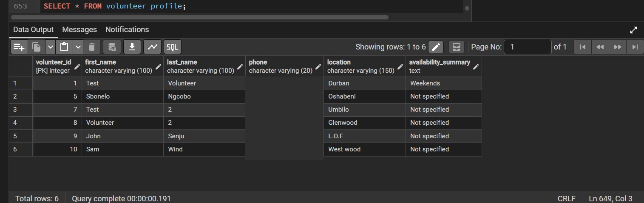
Figure 18. Volunteer profile table showing six saved profiles and their availability summaries (phone numbers masked).
Observed result. Six volunteer profiles were stored, with locations and availability summaries. Contact details are masked in this distributed report.
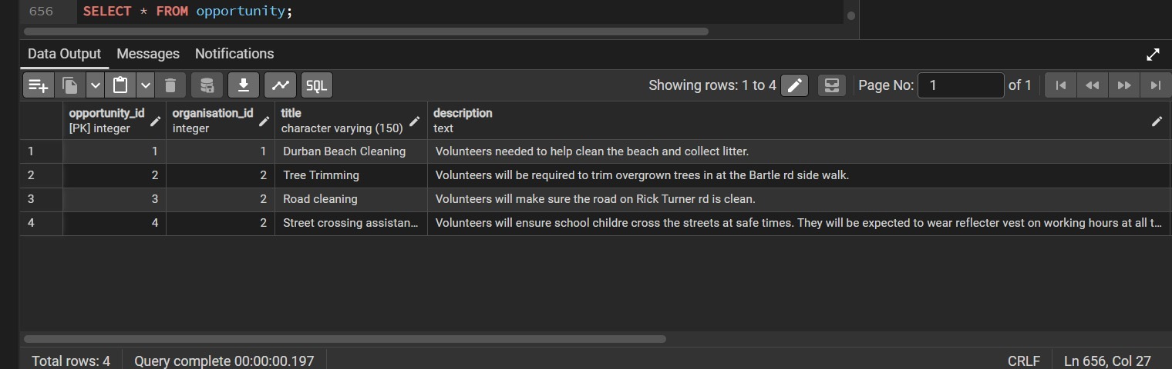
Figure 19. Opportunity table showing four saved activities, including Street crossing assistance.
Observed result. Four opportunity records were present, including the Street crossing assistance record added during the prototype test.
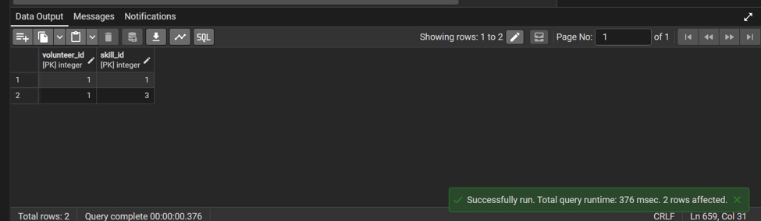
Figure 20. Volunteer_skill association table showing two skill links for volunteer ID 1.
Observed result. The volunteer_skill table stored two links for volunteer ID 1. This verifies associations in the table.
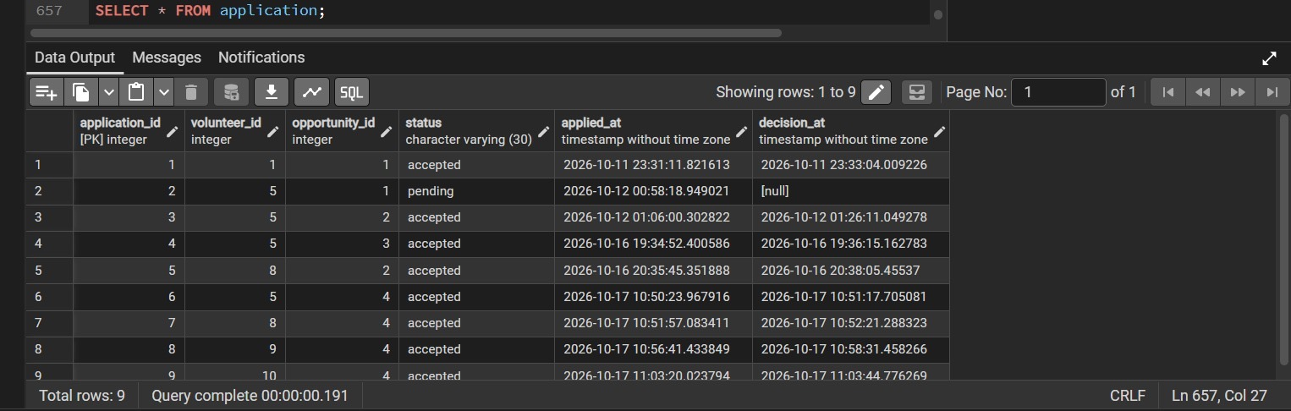
Figure 21. Application table showing nine submissions, eight accepted and one pending, with timestamps.
Observed result. The application table contained nine applications: eight accepted and one pending. Accepted entries displayed decision timestamps, providing persistence evidence for application statuses.
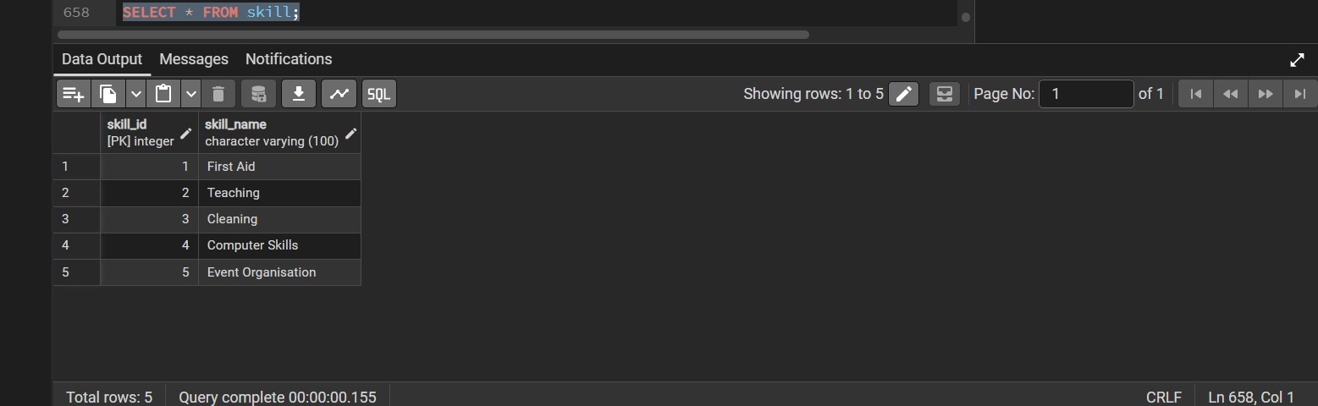
Figure 22. Skill table showing five stored categories: First Aid, Teaching, Cleaning, Computer Skills and Event Organisation.
Observed result. Five reference skills were recorded: First Aid, Teaching, Cleaning, Computer Skills and Event Organisation.
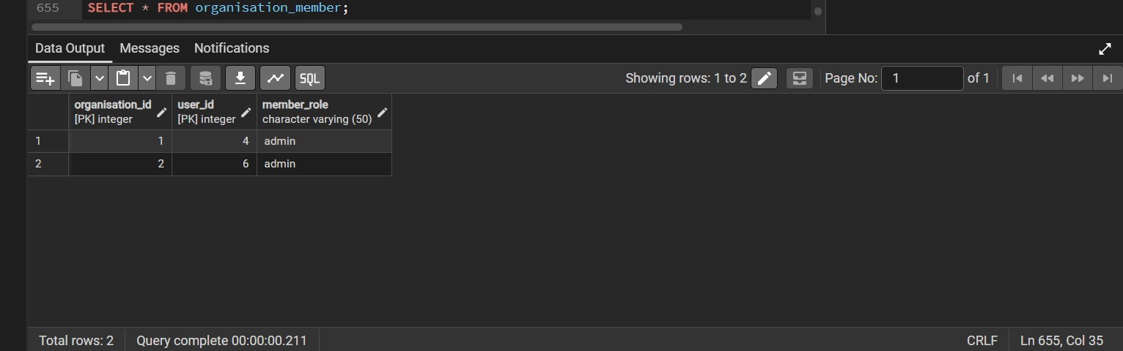
Figure 23. Organisation_member table showing two admin-to-organisation assignments.
Observed result. The organisation_member table stored two links assigning administrator accounts to their corresponding organisations.
The screenshots above provide additional PostgreSQL evidence from the final prototype. They show data stored for organisations, volunteer profiles, opportunities, applications, notifications, skills, volunteer-skill links, organisation membership and chatbot FAQs (Figures 15–23). These screenshots establish the presence and retrieval of saved database records at the time each query was run.

2.5 Interpretation, quality observations and residual risks
Application status persistence is supported by two types of evidence. First, the organisation applicant interface changes the highlighted status from pending to accepted (Figures 4, 5 and 6). Second, the PostgreSQL application table separately contains accepted statuses and decision timestamps (Figure 21). However, because the screenshots are not a controlled before-and-after capture of the same application_id across both interfaces, the database evidence is corroborating rather than a transaction-level audit trail.
The four-row opportunity table (Figure 19) provides a stronger matched persistence example. The administrator published Street crossing assistance through the interface (Figures 8 and 10), the database count increased from three to four with the new title (Figures 9 and 19), and the activity appeared on the volunteer-facing list (Figure 12).
The screenshot for organisation records shows two verification_status values of pending (Figure 17). Consequently, organisation approval and verification is not yet evidenced as completed. Similarly, the FAQ query shows repeated seed questions in the stored records (Figure 16). This is a potential data-quality issue, not proof that the chatbot itself fails. A separate chatbot question-and-answer test and database deduplication check should be recorded before release.
The PostgreSQL query tool displays individual query execution times of roughly 0.17 to 0.38 seconds in these screenshots. These timings are database-console observations only and must not be presented as measured end-to-end API latency, browser page-load time, throughput or performance compliance.
Remaining tests include confirming notification delivery through the user interface, verifying the organisation approval workflow and role-based permissions, verifying rejection handling, testing repeated or invalid applications and full-capacity opportunities, testing multiple chatbot prompts, and comparing counts using controlled timestamps and record IDs.

2.6 Evaluation and outstanding verification
The evidence shows that several central workflows are usable through the integrated prototype, especially the creation of an opportunity followed by database persistence and visibility in the volunteer list. The user-facing success messages and updated application status also indicate that the application and administrator interfaces can communicate with the supporting system for the scenarios shown.
The following checks remain outside the evidence submitted for this section. They should only be reported as passed if the team conducts and records them: invalid logins and role-based access restrictions, duplicate applications, limits when opportunities reach capacity, rejection and volunteer-side status refresh, creation with invalid dates or required fields missing, organisation verification, chatbot response accuracy, mobile responsiveness, performance response times, and recovery after backend or database errors. No response-time, code-coverage or defect-resolution percentages are inferred from screenshots.

3 Defect Log and quality metrics

3.1 Defects detected
Only a single defect was detected.
- Defect ID - D01
- Defect Description - Users can still apply for a volunteering opportunity after it has reached its maximum capacity.
- Expected Behaviour - Once the maximum number of volunteers has been reached, the system should prevent further applications and indicate that the opportunity is full.
- Actual Behaviour - The system still accepts new applications even when the opportunity has no remaining spaces.
- Proposed Action - Add a capacity check before accepting an application. The system should compare the current number of accepted/applying volunteers with the maximum capacity and reject the application when the limit has been reached.
- Status - To be fixed
During system testing, one functional defect was identified in the opportunity application process. The system currently allows users to apply for an opportunity even after the maximum volunteer capacity has been reached. This may result in more volunteers being registered than the opportunity can accommodate. The proposed correction is to validate the opportunity capacity before an application is accepted. If the opportunity is full, the system should reject the application and display an appropriate message to the user.

3.2 quality metrics
Code review was used during the development of the system to improve the quality, readability and maintainability of the source code. The review focused on checking whether the code followed the required functionality, whether input was validated correctly, and whether the API logic was organised clearly.
The opportunity-related code was reviewed on a separate code-review branch before the changes were incorporated into the project. Attention was given to input validation and the handling of opportunity information. The review helped identify areas where validation could be improved and made the code easier to understand and maintain.
The main quality measures considered during the review were:
Quality Metric
Code readability | Code was reviewed to ensure that the logic and structure were understandable.
Input validation | Validation of opportunity information was improved during the code review.
Maintainability | The reviewed code was organised so that future changes can be made more easily.
Error handling | API behaviour was reviewed to ensure invalid input could be handled appropriately.
Version control | Changes were tracked using Git branches and commit history.
Known functional defects | One defect remains: users can apply after an opportunity has reached capacity.

$$Defect resolution rate=\frac{Defects Resolved}{Total Defects Identified}×100=\frac{0}{1}=0$$
$$Review Coverage=\frac{Lines Reviewed}{Lines Changed}×100$$

3.3 Verified Github Link
The source code for the Community Volunteer Coordination Platform is stored and managed using GitHub. The repository was verified to ensure that the link is accessible and that it contains the project files required for submission.
The repository contains the main project components, including the backend, frontend, database, documentation and screenshots. It also contains the project README.md and a visible commit history showing the development progress of the system. At the time of verification, the repository contained 55 commits.
Repository name: Community-Volunteer-Coordination-Platform
Repository status: Public
Main branch: main
GitHub repository link: https://github.com/mphommarindi-prog/Community-Volunteer-Coordination-Platform

Conclusion
The Community Volunteer Coordination Platform was developed as an integrated system to connect volunteers with organisations offering community volunteering opportunities. The platform allows volunteers and organisations to register and log in, while organisations can post and manage opportunities and volunteers can browse available opportunities, submit applications and receive application decisions. The system uses a PostgreSQL database to store and manage information, supporting the consistent handling of user accounts, volunteering opportunities and applications.
The project incorporated software engineering principles, including user-centred design, system modelling, database design, coding standards, error handling and security conventions. The user interface was designed to support the different needs of Volunteers and Organisation Administrators, providing a structured way to access the system's main functions. GitHub was used for version control and collaboration, allowing the development team to manage source code and track changes throughout the project.
In conclusion, the Community Volunteer Coordination Platform provides a foundation for improving the organisation and coordination of community volunteering activities through a centralised digital solution. Future enhancements could include improved notifications, more advanced opportunity filtering, enhanced volunteer management and online deployment to make the platform accessible to a wider community.

